
Sut rwy’n trefnu a chynnal sgwrs adolygu a phontio?
Cam | Beth sydd angen digwydd | Wedi gweithredu
1 | Gwirio ar y system electronig er mwyn adnabod plant sy’n gweithredu ar y lefel targedu (proffil mewn lle) ac yn trosglwyddo Medi.  Mae posib i chi holi eich athrawes ymgynghorol neu cysylltu gyda swyddog arweiniol ADY (Ellen Jones) os nad ydych chi’n gallu adnabod y plant.
2 | Ystyried pwy sydd angen bod yn rhan o’r sgwrs.  Mae rhaid cynnwys:  - Lleoliad presennol  - Rhiant / gwarchodwr  - Lleoliad Newydd (ysgol)  Ystyried os oes angen cynnwys rhywun arall e.e.athrawes tim nam synhwyraidd, YI, Swyddog Datblygiad Cynnar, swyddog Cefnogi Teulu (dim ond os oes ganddynt rywbeth ychwanegol i gyfrannu i’r hyn sydd wedi’i nodi yn y proffil)
3 | Ystyried os ydych chi’n cynnal cyfarfod rhithiol neu wyneb yn wyneb  Rhannu gwahoddiad (cynnwys linc teams os ydych chi'n cynnal cyfarfod rhithiol) gan gynnwys pawb mewn un e-bost (gweler enghraifft isod)
4 | Rhannu gwahoddiad i’r proffil ar y system electronig gyda’r ysgol (gweler llun isod sy’n dangos sut i wneud hynny – cysylltu gyda’ch athrawes ymgysylltiol neu Ellen Jones Swyddog Arweiniol os oes angen cefnogaeth pellach)
5 | Sicrhau bod proffil tracio blynyddoedd cynnar wedi’i ddiweddaru a’i uwchlwytho ar y system electronig ac eich bod yn ymwybodol o beth sy’n gweithio / ddim yn gweithio o ran datblygiad a darpariaeth
6 | Trefn y Sgwrs:  - cyflwyniadau  - cyfle i bawb rannu beth sy’n gweithio  - cyfle i bawb rannu beth sydd ddim yn gweithio  - Ystyried camau gweithredu e.e. addasu’r proffil, cyfeirio at wasanaeth, camu lawr o’r lefel targedu  - Rhannu unrhyw wybodaeth berthnasol arall  Cofnodi’r sgwrs ar Ff1 neu tab cyfarfodydd ar y system electroneg (gweler llun isod)

***************************************************************************Templed e-bost i gyd fynd a’r gwahoddiad: gellir Copïo a phastio’r gwybodaeth isod gan ychwanegu enw’r plentyn yn y rhan melyn a chynnwys rhan glas os ydy’r plentyn yn trosglwyddo i leoliad newydd.
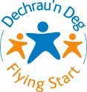
Rydym yn awyddus i drefnu sgwrs i drafod beth sy’n gweithio / ddim yn gweithio i Enw plentyn a diweddaru’r proffil un dudalen.

Hefyd, bydd cyfle i drosglwyddo gwybodaeth gyda enw’r lleoliad newydd.
Dyddiad:
Amser:
Lle?
Byddwn yn ddiolchgar petai chi’n ymateb i’r gwahoddiad.
Cofion

Rhannu gwahoddiad gyda’r ysgol.
- Clicio ar y symbol person ac arwydd adio
- Sgrolio lawr at ‘mynediad i leoliadau addysgol eraill’ – fel gwelir yn y llun isod
- Clicio ar y bocs glas ‘ ychwanegu lleoliad’
- Dewis yr ysgol yn y cwymp restr.
- Clicio ar y bocs ‘ychwanegu’

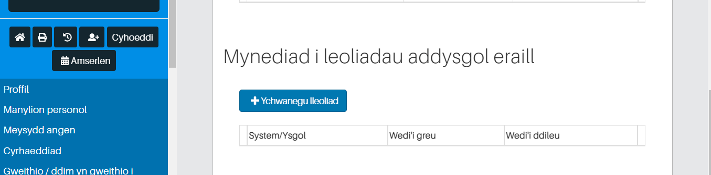
Cofnodi sgwrs adolygu
Opsiwn 1 – Ff1 (templed ar gwefan ADY – Gwasanaeth Blynyddoedd Cynnar)
Opsiwn 2 – defnyddio tab cyfarfodydd ar y system electronig (gweler llun isod)
- Clicio ar y tab ‘cyfarfodydd’
- Clicio ar y bocs ‘ychwanegu cyfarfod’
- Cofnodi gwybodaeth yn y bocsys
- Pwyso arbed
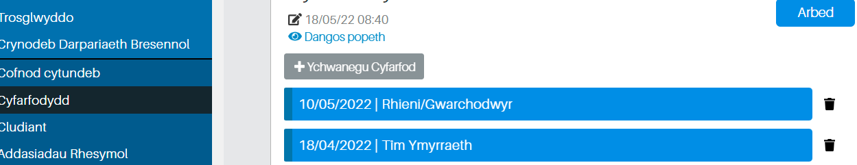
How do I organise and conduct a review and transition conversation?
step | What needs to happen
1 | Check the electronic system to identify children who are operating at the target level (profile in place) and transferring in September. Children with date of birth between 01/09/2018 and 31/08/2019.  You can ask your advisory teacher or contact the ALN lead officer (Ellen Jones) if you cannot identify the children.
2 | Consider who needs to be part of the conversation.  Must include:  1) Current location  2) Parent / guardian  3) New Location (school)  Consider if someone else needs to be involved e.g. HV, Early Development Officer, Family Support Officer (only if they have something extra to contribute to what is mentioned in the profile)
3 | Consider if you are holding a virtual or face-to-face meeting  Invite sharing (include teams link if hosting a virtual meeting) including everyone in one email (see example below)
4 | Share invitation to the profile on electronic system with school (see image below showing how to do so - contact Ellen Jones Lead Officer if further support required)
5 | Ensure that the early years tracking profile is updated and uploaded onto the electronic system and that you are aware of what works / doesn't work in terms of development and provision
6 | Conversation Order:  1) introductions  2) an opportunity for everyone to share what works  3) an opportunity for everyone to share what’s not working  4) Consider actions e.g. adjust profile, refer to service, step down from target level  5) Share any other relevant information  Record the conversation on Ff1 or the meetings tab on the electronic system (see image below)

Email template to accompany invitation: The information below can be copied and pasted with the child's name added in yellow and blue if included in a new placement.

We would like to arrange a chat to discuss what works / doesn't work for child's Name and to update the one page profile.
There will also be an opportunity to plan the transition to name of the new location.
Date:
Time:
Place?
I would be grateful if you would respond to the invitation.
Regards
**************************************************************************
Share invitation to the electronic system with the school.
1. Click on the person symbol and addition sign
2. Scroll down to 'access to other educational settings' - as shown in the picture below
3. Click the 'add location' blue box
4. Choosing the school in the drop down
5. Click the 'add' box

Record a review conversation
Option 1 - Ff1 (template on ALN ​​website - Early Years Service)
Option 2 - use the meetings tab on the electronic system (see image below)
1. Click the 'meetings' tab
2. Click the 'add meeting' box
3. Record information in the boxes
4. Press save

