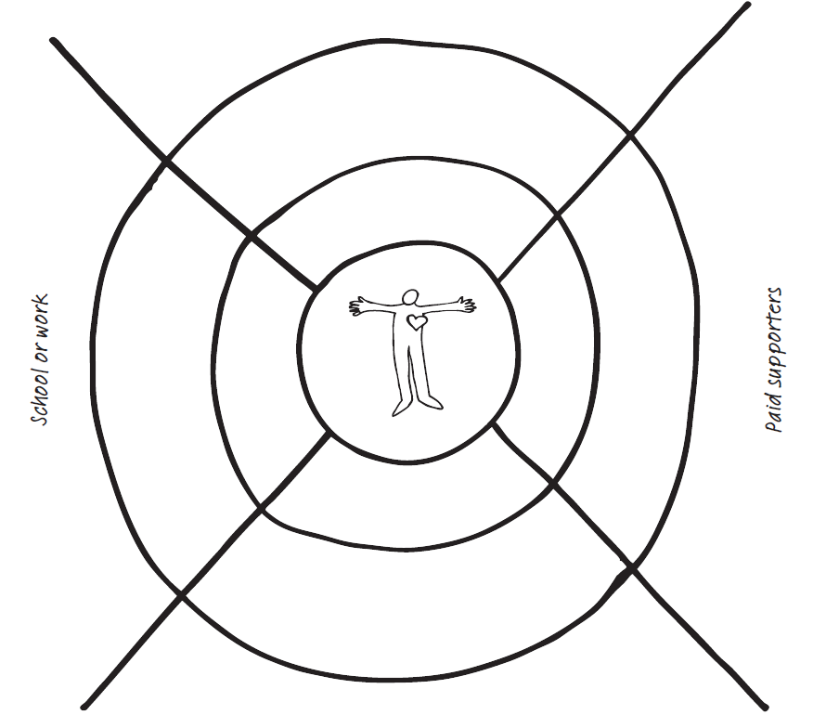
Ffrindiau /friends
Pobl a gaiff eu talu i fy nghefnogi. People who are paid to support me
Teulu / Family
Lleoliad / setting

