
Breathing strategies

1) Breathing chart – 5 deep breaths (see resources)
2) Breathing in and out moving their finger up and down the fingers of the other hand (if the child does not want to touch their hand, a card can be used in any shape e.g. a star with the sides covered with sand/glitter in order to add the sensory element – the child can run his / her finger along the side of the shape when breathing in and out
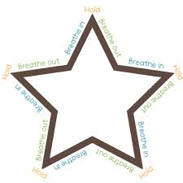
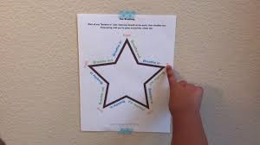

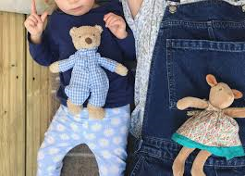
3) Lying on a floor placing a teddy on their belly and encourage them to breath in and out (child seeing Teddy moving)

4) Lying on a floor, breathing in and out by using their finger to make a circle shape on their palm of their other hand (helping a child to relax). If the child is having difficulty a member of staff can do this to them.
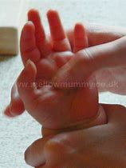

5) Blowing bubbles (fostering control over their breathing)
6) Use a straw to make bubbles with their drink – the bubble must be kept inside the cup (control over breathing)
7) Swshaswyn Programme – Cyw (scan codes QR)
Ymarfer Seren Ymarfer Fflwff




