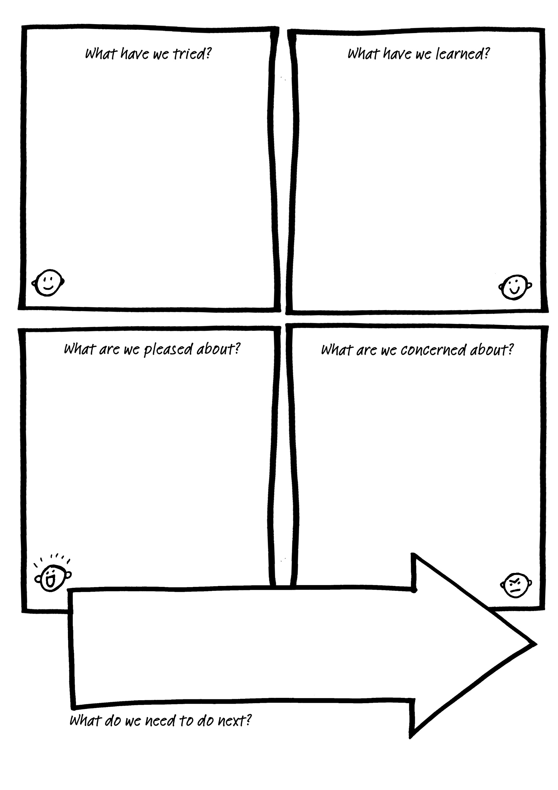
A chofio hyn rydym yn ei wybod nawr, beth nesaf?
Given what we know now, what's next?

Am beth rydym yn bryderus?.
What are we concerned about?

Am beth rydym yn falch?.
What are we pleased about?

Beth rydyn ni wedi ei ddysgu?
What have we learned?

Beth rydyn ni wedi rhoi cynnig arno?
What have we trïed?

Beth ydyn ni’n pryderu amdano?
What are we concerned about?
Beth ydyn ni wedi rhoi cynnig arno? What have we tried?
Beth ydyn ni’n falch amdano?
What are we proud of?

Beth ydyn ni wedi’i ddysgu?
What have we learned?

